**“E-KETHA” : ENRICHING RICE FARMER’S QUALITY OF LIFE THROUGH A MOBILE APPLICCATION.**

2022-81

Project Status Document 2 – Individual

K.M.Umesh Ranthilina – IT19240152

Supervisor: Mr. Adeepa Gunarathna

Co Supervisor: Ms. Amali Upeka Gunasinghe

B.Sc. (Hons) Degree in Information Technology

Department of Computer Science and

Software Engineering

Sri Lanka Institute of Information Technology

Sri Lanka

November 2022

**TABLE OF CONTENTS** ii

1. Microsoft Teams Chat and Meetings 1

2. Call of MS Teams 2

3. Microsoft planner overall analysis of tasks 4

4. Work Breakdown Structure 6

5. Grant Chart 7

# Microsoft Teams Chat and Teams Chat and Meetings

# Call of MS Teams

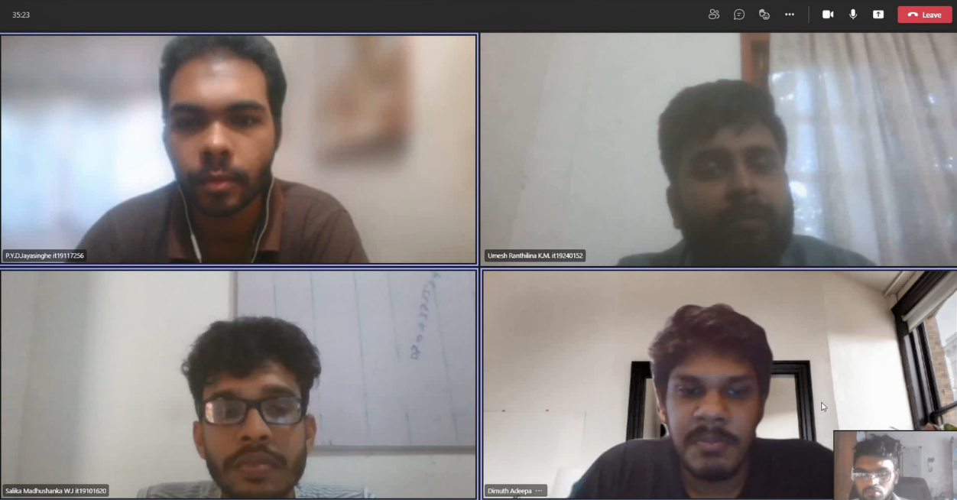

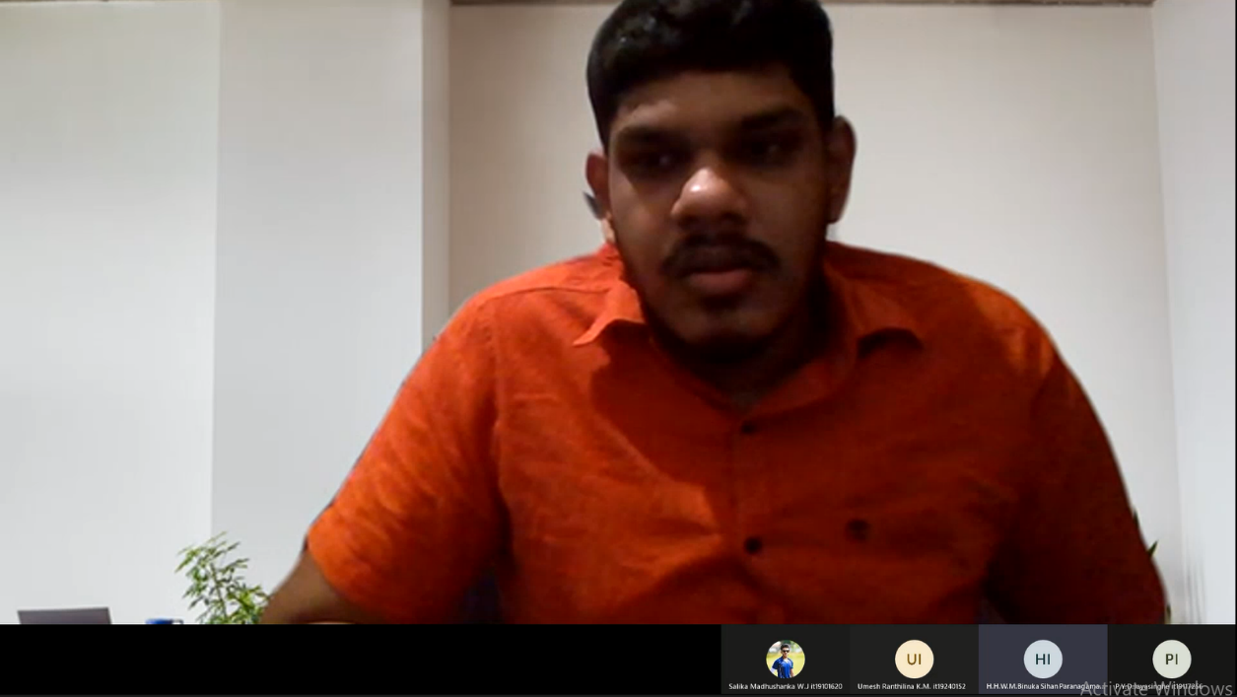

# Microsoft planner overall analysis of tasks

# Work Breakdown Structure

# Grant Chart

